>Format Reference
https://cal.com/help/welcome
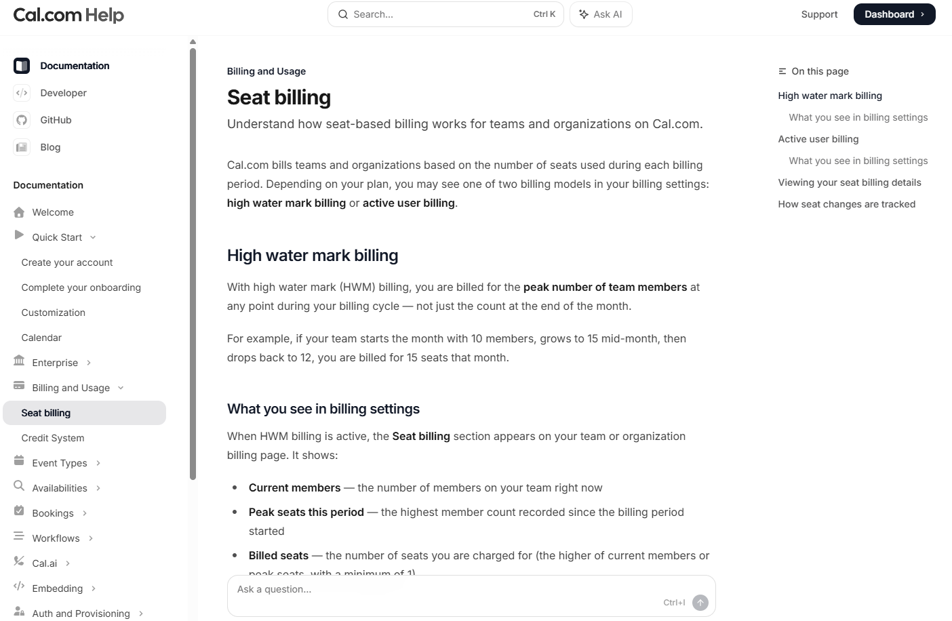

>User Dashboard

Metadata:
/docs/help/dashboard

Dashboard (Right Side)
- Overview
- Storage
- Interviews
- Resumes & Attachments
- Metrics & Limits

Content:
Dashboard
Manage your interviews, resumes, storage, and account activity from a single centralized view.

What this page is
The Dashboard is your control center for OpenInterview.
It provides:
- Storage usage (video + documents)
- Interview performance metrics
- Quick access to interviews and resumes
- Plan limits and upgrade options

When to use this page
Use the Dashboard to:
- Monitor how many interviews you’ve created and shared
- Track views and engagement
- Manage uploaded resumes and attachments
- Check storage limits
- Upgrade your plan when needed

Page overview
The Dashboard is divided into five main sections:
- Storage usage
- Performance metrics
- Plan status and upgrade
- Interviews table
- File management (resumes and attachments)

Storage usage
Displays how much storage you are using across your account.
Video storage
Shows how much video storage is used for recorded interviews.
- Format: X MB / Y GB
- Includes:
  - Recorded interview videos
  - Uploaded video responses
Document storage
Tracks uploaded files such as resumes and attachments.
- Format: X KB / Y MB
- Includes:
  - PDF resumes
  - Images
  - Supporting documents
Notes
- Storage limits are based on your plan
- Exceeding limits may prevent new uploads

Performance metrics
Provides a quick snapshot of your activity.
Shares (Published)
Number of interviews currently published and shareable.
- Format: X / Y
- X = active published interviews
- Y = total allowed based on your plan
Total views
Total number of views across all shared interviews.
- Includes:
  - Public profile views
  - Shared link visits
Bookings
Shows interview booking activity.
- Locked behind paid plans
- Displays as:
  - 0 / 0 for free users
  - Active counts for paid users

Plan and upgrade
Displays your current plan limitations and upgrade options.
Upgrade panel
Includes:
- Call-to-action: Upgrade Plan
- Message explaining benefits:
  - More shares
  - Booking access
  - Increased limits
When to upgrade
You should consider upgrading if:
- You’ve reached your share limit
- You need booking functionality
- You require more storage

My Interviews
Displays all interviews created in your account.
Table columns
Column | Description
Title | Name of the interview
Date | Creation date
Shared | Whether the interview is publicly shared
Views | Number of views
Status | Draft or Published
Actions | Available actions

Status types
- Draft
  - Not visible publicly
  - Cannot be shared
- Published
  - Publicly accessible
  - Can be shared via link

Actions
Each interview includes the following actions:
- View profile
- Share interview
- Edit interview
- Delete interview

Sharing rules
- Only published interviews can be shared
- Draft interviews must be published first

My Resumes
Displays all uploaded resumes.
Table columns
Column | Description
File Name | Name of the uploaded resume
Upload Date | Date uploaded
Size | File size

Notes
- Multiple versions of the same resume can be uploaded
- Used for:
  - Interview profiles
  - Sharing with employers

My Attachments
Displays additional uploaded files.
Supported file types
- Images (PNG, JPG)
- Videos (MP4)
- Documents
Table columns
Column | Description
File Name | Name of the file
Upload Date | Date uploaded
Size | File size

Common uses
- Portfolio samples
- Supporting documents
- Profile assets

Common workflows
Create and share an interview
- Click New Interview
- Complete interview setup
- Publish the interview
- Share the generated link

Upload a resume
- Navigate to Dashboard
- Scroll to My Resumes
- Upload file
- Attach to interview if needed

Monitor engagement
- View Total Views
- Check individual interview views
- Identify high-performing profiles

Manage storage
- Review storage bars
- Delete unused files if needed
- Upgrade plan if approaching limits

Limitations (Free plan)
- Limited number of published interviews
- No booking functionality
- Lower storage limits

>Creating Your First Openinterview
Metadata:
/docs/help/create-first-openinterview
Create Your First OpenInterview (Right Side)
- Overview
- Upload Your Resume
- Resume Processing
- Generated Profile Overview
- Profile Header & Actions
- Video Section
- Profile Summary Card
- Bookings (Calendar)
- Attachments & Connect
- Highlights
- Resume Preview
- Next Steps (Edit, Video, Availability, Share)

>Content
Create Your First OpenInterview
Create your first OpenInterview by uploading your resume, letting the platform generate your initial profile, and then refining the content before sharing it publicly.

What this guide covers
This guide walks through the first part of the OpenInterview setup flow:
- Upload your resume
- Wait while your resume is processed
- Review the generated profile
- Understand each section of the new profile page
- Move to the next step: editing, video, calendar, and sharing

Before you begin
Make sure you have:
- an up-to-date resume in PDF format
- your preferred role title and summary in mind
- a headshot, profile image, or intro video ready if you plan to personalize the page further

Step 1: Upload your resume
On the OpenInterview creation page, start by uploading your resume using the upload box.
What you will see
The page includes:
- a large headline introducing the OpenInterview experience
- a drag-and-drop upload area
- a Browse Files button for manual upload
How to upload
You can upload your resume in either of two ways:
Drag and drop
Drag your resume file directly into the upload box.
Browse files
Click Browse Files and select your resume from your device.
What happens after upload
Once the file is accepted:
- the file name appears below the upload area
- OpenInterview begins processing the document automatically
- you move into the resume analysis stage

Step 2: Resume processing
After upload, OpenInterview analyzes your resume and prepares your first profile draft.
What the processing screen shows
The processing state includes:
- the uploaded file name
- a progress bar
- a percentage indicator
- a status message such as “Finalizing setup...”
What OpenInterview is doing during this step
At this stage, the platform is extracting and organizing information from your resume, including:
- your name
- current or target role
- location
- professional summary
- key highlights
- resume content
- profile-ready formatting for the public page
What to expect
Processing usually results in:
- a structured profile layout
- automatically generated content blocks
- a profile page that is ready for review and editing

Step 3: Review your generated profile
Once processing is complete, OpenInterview takes you to your newly created profile page.
This page is your first live interview profile draft. It is already populated with information from your resume and structured into shareable sections.
At this stage, the profile is meant to give you a strong starting point. You will still review and edit it before sharing.

Profile page overview
The generated profile page is organized into a main content area and a right-side profile panel.

Top action bar
At the top of the page, you will see a welcome banner and primary actions.
What this section includes
- a greeting with your name
- a short message explaining this is your public interview page
- an Edit Profile button
- a Share button
What this section means
This is the control area for your profile.
Edit Profile
Used to refine and update each section of the page.
Share
Used later, after your profile is ready to publish and distribute.
At this stage, the most important next action is Edit Profile.

Main video section
The large video area is the centerpiece of the profile page.
What this section is for
This is where your OpenInterview video introduction will appear.
What you see initially
Before uploading a video, this section may display:
- a placeholder player state
- a thumbnail area
- a play button overlay
What it becomes later
After you upload your video, this section becomes the main recorded introduction recruiters and employers will watch first.
Why it matters
This is the most important personal element on the page because it turns your resume into a more human, differentiated profile.

Right-side profile card
The right column contains your core candidate summary.
What this section includes
- profile image or avatar
- full name
- role title
- location
- short professional summary
How it is generated
This content is initially pulled from your resume and arranged into a concise candidate snapshot.
What to review here
You should check:
- name formatting
- title accuracy
- location accuracy
- summary tone and clarity
Why this section matters
This is the fastest way for a viewer to understand who you are and what type of role you fit.

Bookings panel
Below the profile summary card is the bookings calendar section.
What this section is for
This is where viewers will eventually see your interview availability and request time with you.
What you may see initially
At this stage, the calendar may show:
- a month view
- timezone information
- no available slots yet
Why it is empty at first
Availability has not been configured yet. This will be set during the next step when you edit the profile and define your calendar schedule.
What happens later
After availability is configured, this section becomes your live booking area.

Attachments section
On the left side under the main video area, you may see an Attachments section.
What this section is for
This area is used to display supporting files that help strengthen your profile.
Examples of attachments
- portfolio files
- certifications
- work samples
- supplemental documents
What you may see initially
If nothing has been uploaded yet, this section may show that no attachments are available.

Connect section
Below Attachments is the Connect section.
What this section is for
This area gives viewers additional ways to learn about you or connect with your professional presence.
Common example
- LinkedIn profile link
Why it matters
This helps extend your profile beyond the OpenInterview page and gives recruiters another trusted source of professional context.

Highlights section
The Highlights section presents your experience in quick, readable bullet points.
What this section includes
This content is generated from your resume and may include:
- years of experience
- technical strengths
- role specialization
- workflow or domain expertise
- collaboration or leadership strengths
Why this section matters
It gives hiring teams a fast scan of your strongest qualifications without reading the full resume first.
What to review
You should confirm:
- the bullets are accurate
- the most important strengths are represented
- the wording matches how you want to present yourself

Resume section
Further down the page, the full resume is embedded directly into the profile.
What this section includes
- a preview of the uploaded resume
- the original file name
- a Download Resume button
What this is for
This lets viewers:
- read the full resume without leaving the page
- download it directly if needed
Why it matters
It combines the benefits of a modern profile page with the practicality of a traditional resume.

What OpenInterview has done for you so far
By the time you reach this page, OpenInterview has already:
- accepted your uploaded resume
- processed the document
- extracted your core candidate details
- created a formatted public profile structure
- generated summary content and highlights
- embedded your resume into the page
- prepared a booking section for future availability setup
This gives you a complete starting point rather than a blank profile.

What to review before editing
Before clicking Edit Profile, review the generated page for:
Identity details
- correct name
- correct role title
- correct city or location
Summary quality
- accurate positioning
- clear wording
- professional tone
Highlights
- strongest points included
- phrasing aligned with your goals
Resume preview
- correct file
- readable formatting
- correct download behavior
Page completeness
- whether you want attachments
- whether you want external links such as LinkedIn
- whether the profile is ready for a video and calendar setup

Next step: Edit your profile
Once your initial profile has been created, the next step is to click Edit Profile.
In the editing flow, you will:
- refine the wording in each section
- update your summary and highlights
- add or revise links and attachments
- set calendar availability
- upload your profile video
- prepare the page for sharing

What comes next
The next stage of setup is where your draft becomes a polished, public-facing OpenInterview profile.
This includes:
- final verbiage
- video upload
- booking availability
- sharing your profile link

>Editing Your OpenInterview
Metadata:
/docs/help/edit-profile
Edit Your OpenInterview Profile (Right Side)
- Overview
- Profile Name & Auto-Populate (Optional Resume Upload)
- Profile Photo
- Video Upload & Thumbnail
- Contact Information & Short Bio
- Social Media Links
- Resume (Manage File)
- Attachments
- Highlights
- Skills
- Experience
- Education
- Availability (Weekly Hours)
- Scheduling Rules (Booking Settings)
- Save & Share Your Profile

>Content
Edit Your OpenInterview Profile
Refine, personalize, and complete your OpenInterview profile before sharing it publicly.

What this page is
The Edit Profile page is where your automatically generated profile becomes a polished, recruiter-ready experience.
After your resume is processed, OpenInterview creates a strong draft. This page allows you to:
- refine wording
- add personal elements
- configure availability
- prepare your profile for sharing

When to use this page
Use this page to:
- finalize your profile content
- upload your video introduction
- adjust highlights, skills, and experience
- configure booking availability
- prepare your profile for public sharing

Page overview
The Edit Profile page is structured top-to-bottom in the following sections:
- Profile setup and resume (optional)
- Identity and media (photo + video)
- Personal details (bio, contact, links)
- Resume and attachments
- Professional content (highlights, skills, experience, education)
- Availability and booking rules
- Save and share

Profile setup
Profile Name
Defines the title of your OpenInterview.
Example
Rajesh Venkataraman – Data Engineer
Best practice
- Use: Full Name – Role
- Keep it clear and professional
- This may be visible when shared

Auto-populate with Resume (Optional)
Upload a new resume to regenerate profile content.
Important
This step is optional.
Most users can skip this because:
- your profile has already been generated from your original resume
- all sections can be edited manually below
When to use this
Use this only if:
- you want to replace your original resume
- you have a more updated or targeted version
- you want to regenerate highlights and content automatically
Actions
- Upload resume
- Click Auto-populate from Resume

Identity and media
Profile Photo
Upload or update your profile image.
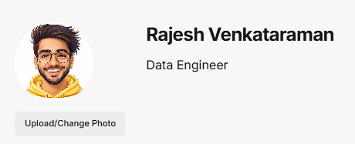
Why it matters
- Adds credibility and personalization
- Helps recruiters quickly recognize you
Best practices
- Use a clear, professional headshot
- Neutral background preferred

Video section
Upload your OpenInterview video introduction.
What this section includes
- Video player preview
- Change Video button
What to do
- Upload or replace your video
- Ensure audio and framing are clear
Why it matters
This is the most important part of your profile.
It allows recruiters to:
- hear how you communicate
- understand your personality
- evaluate fit beyond the resume

Video Thumbnail
Upload a custom thumbnail image for your video.
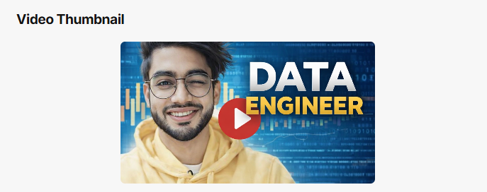
Why it matters
- This is the first visual impression
- Impacts whether someone clicks to watch
Best practices
- Use a clear, professional still
- Avoid blurry or dark images

Personal details
Contact Information
Includes:
- Location
- Telephone
- Email
Notes
- Keep information accurate and professional
- Only include contact details you are comfortable sharing

Short Bio
A concise summary of your professional background.
What it should include
- years of experience
- core strengths
- technical or domain expertise
- type of roles you are targeting
Best practice
- Keep it 2–4 sentences
- Clear, confident, and direct

Social Media
Add external links to your professional presence.
Common links
- LinkedIn (recommended)
- Portfolio site
- GitHub (for technical roles)
Actions
- Add new link
- Select platform type
- Enter URL
- Remove if needed

Resume and attachments
Resume
Displays your uploaded resume.
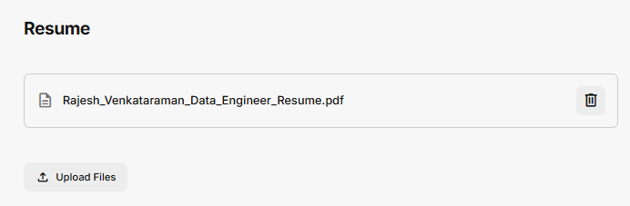
Actions
- Upload new file
- Replace existing file
- Delete file
Notes
- This is the version visible on your profile
- Ensure it is up to date

Attachments
Upload additional supporting files.
Examples
- Portfolio samples
- Certifications
- Project documents
- Case studies
Notes
- Optional but valuable for differentiation

Professional content
Highlights
Short bullet points summarizing your strengths.
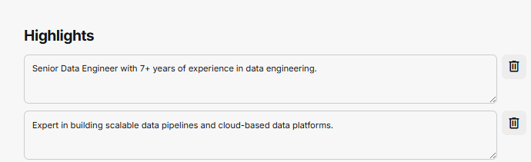
What to include
- experience level
- technical strengths
- impact statements
- domain expertise
Actions
- Edit existing highlights
- Delete highlights
- Add new highlight
Best practices
- Keep each point concise
- Focus on impact and clarity

Skills
Add key skills as tags.
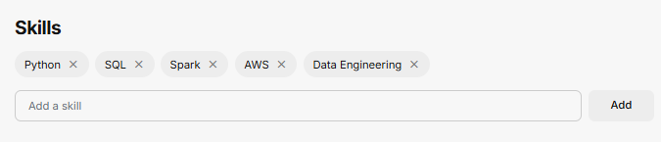
Examples
- Python
- SQL
- AWS
- Data Engineering
Actions
- Add new skill
- Remove skill
Best practices
- Focus on relevant, role-aligned skills
- Avoid overloading with too many entries

Experience
Add or edit your work experience.
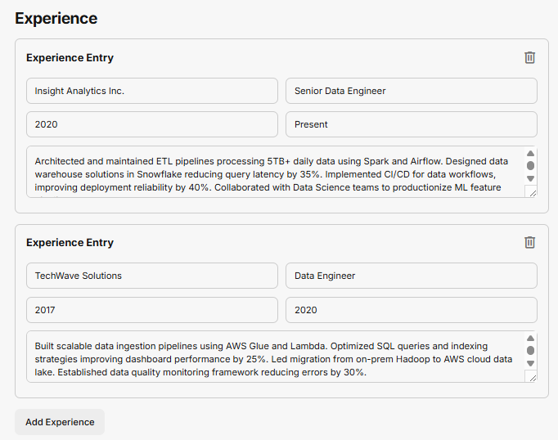
Each entry includes
- Company name
- Role title
- Start and end dates
- Description
Description guidance
- Focus on impact, not just responsibilities
- Use metrics where possible
- Keep it concise and readable
Actions
- Add experience
- Edit entries
- Delete entries

Education
Add your academic background.
Each entry includes
- Institution
- Degree
- Field of study
- Year
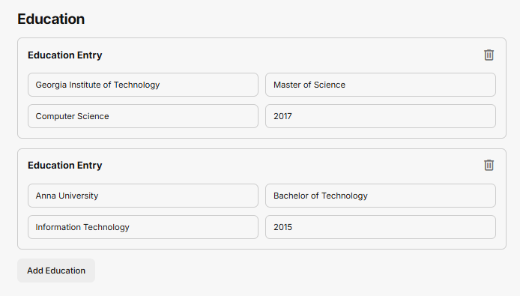
Actions
- Add education
- Edit entries
- Delete entries

Availability (Bookings)
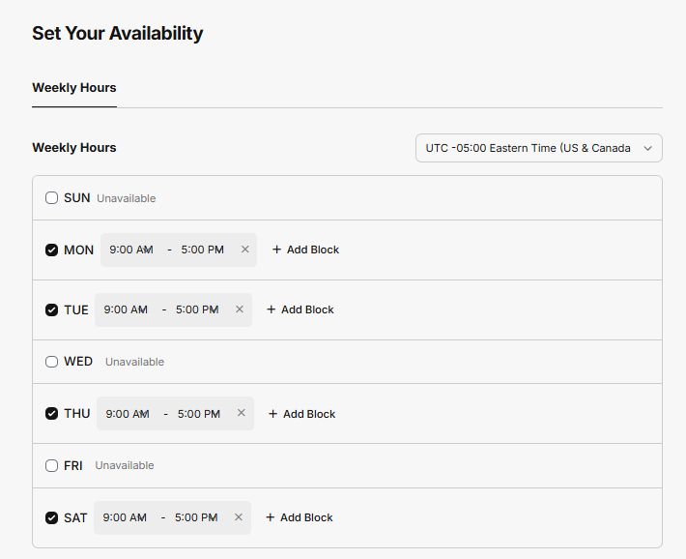
Weekly Hours
Define when you are available for bookings.
How it works
- Select days you are available
- Set time ranges for each day
- Choose your timezone
Notes
- If no days are selected, no bookings will be available
- This controls your public calendar

Quick Actions
Shortcuts to manage availability:
- Copy daily hours to all days
- Set all to unavailable
- Clear all hours
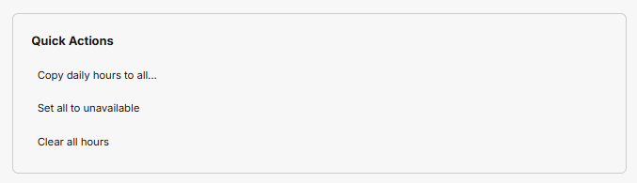

Scheduling Rules
Configure how bookings work.
Minimum Notice
Minimum time before someone can book.
Example: 24 hours
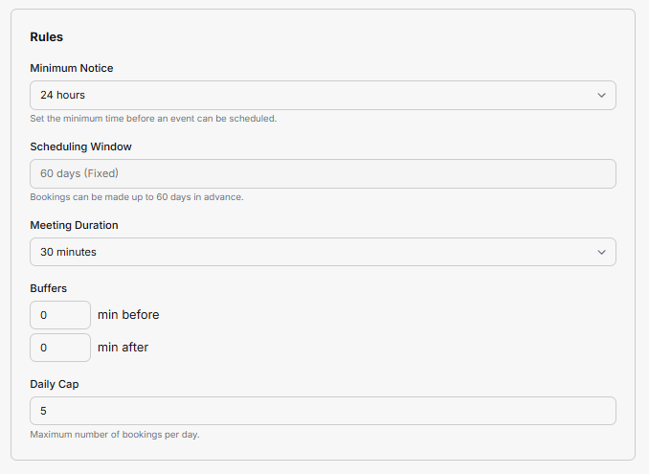

Scheduling Window
How far in advance bookings can be made.
Example: 60 days

Meeting Duration
Length of each booking.
Example: 30 minutes

Buffers
Time before and after each booking.
Example:
- 0 min before
- 0 min after

Daily Cap
Maximum number of bookings per day.
Example: 5

Save your profile
Save Updates
Click Save Updates to apply all changes.
Important
Changes are not applied until saved.
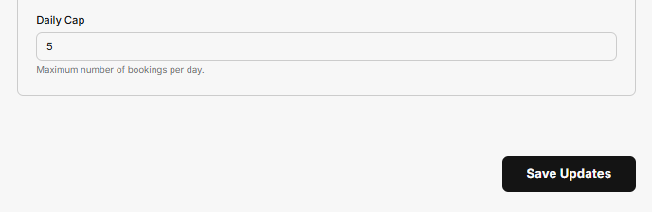

Final step: Share your profile
Once your profile is complete:
- Save all updates
- Return to your profile page
- Click Share
You can now:
- send your profile link to recruiters
- include it in applications
- use it as a modern alternative to a resume

What a complete profile includes
Before sharing, make sure you have:
- profile photo
- video introduction
- polished bio
- strong highlights
- updated experience
- relevant skills
- resume uploaded
- availability configured

>Sharing Your Openinterview
Metadata
/docs/help/share-profile
Share Your OpenInterview Profile (Right Side)
- Overview
- Return to Profile Page
- Share Button
- Share Modal Overview
- Share via Email
- Add a Personal Message (Optional)
- Send Invite
- Copy Profile Link
- When to Share
- Best Practices

Share Your OpenInterview Profile
Once your profile is complete and saved, you can share it with recruiters, hiring managers, or anyone reviewing your candidacy.

What this step is
This step allows you to distribute your OpenInterview profile using:
- direct email invitations
- a shareable profile link
Your profile is now fully live and ready to be viewed.

When to share your profile
You should share your profile after:
- completing all sections (bio, highlights, experience)
- uploading your video introduction
- setting your availability (if using bookings)

Return to your profile page
After clicking Save Updates in the Edit Profile screen, you are returned to your public profile page.
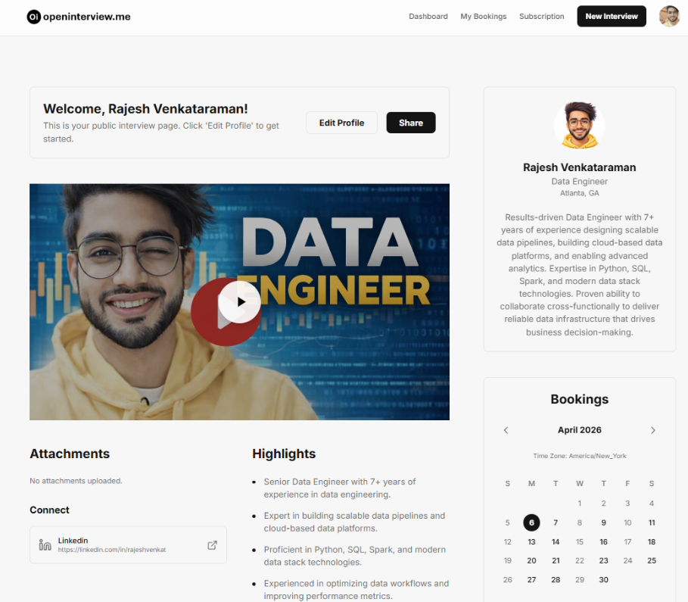
What you will see
Your profile now includes:
- your video (if uploaded)
- updated bio and highlights
- resume preview
- profile image
- booking calendar (if configured)
At the top of the page, you will see two main actions:
- Edit Profile
- Share

Share button
Click the Share button to open the sharing interface.
What this does
- Opens a modal window
- Allows you to send or copy your profile
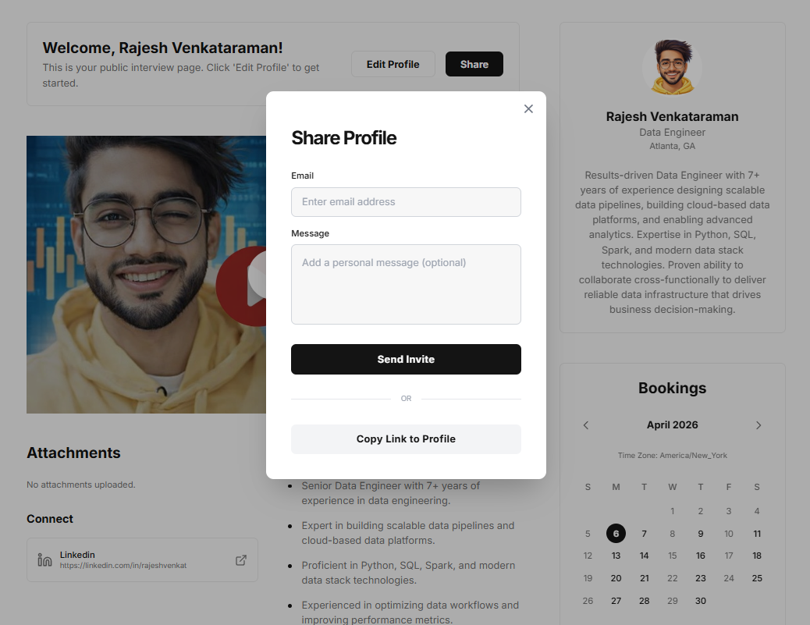

Share modal overview
The Share Profile modal includes two primary ways to share your profile:
- Send via email
- Copy a direct link

Share via email
You can send your profile directly to someone’s inbox.
Fields
Email
Enter the recipient’s email address.
Message (optional)
Add a short message to personalize your outreach.
Example message
“Hi, I’d love for you to take a look at my OpenInterview profile. It includes a video introduction and highlights of my experience.”

Send invite
Click Send Invite to email your profile.
What happens
- The recipient receives a link to your profile
- Your message (if included) is sent with it
- They can immediately view your profile

Copy profile link
Alternatively, you can copy a direct link to your profile.
How to use
Click Copy Link to Profile
What you can do with the link
- paste into job applications
- send via LinkedIn messages
- include in email outreach
- add to your resume or portfolio

When to use each option
Use email sharing when:
- you are applying directly to a recruiter
- you want a personalized introduction
- you are following up after a conversation
Use link sharing when:
- applying through job portals
- networking on LinkedIn
- sharing broadly across channels

What recruiters see
When someone opens your profile, they will see:
- your video introduction
- your professional summary
- key highlights
- resume preview and download
- attachments (if included)
- booking calendar (if enabled)

Best practices for sharing
Keep your message short and direct
Avoid long explanations. Let your profile do the work.
Always include your video
Profiles with video significantly increase engagement.
Tailor your message when possible
A personalized message improves response rates.
Use your link consistently
Include it in:
- job applications
- email signatures
- LinkedIn outreach

You’re now live
At this point, your OpenInterview profile is:
- complete
- shareable
- ready for recruiters
This replaces the traditional static resume with a dynamic, interactive profile.

>Create Additional Openinterivews

Metadata
/docs/help/create-new-openinterview
Create a New OpenInterview (Right Side)
- Overview
- Access New Interview
- New Editor Overview
- Upload Resume (Required)
- Auto-Populate Profile
- Continue Profile Setup
- Save & Share

Create a New OpenInterview
After creating your first OpenInterview, you can create additional profiles for different roles, opportunities, or resume variations.

What this step is
This flow allows you to create a new, separate OpenInterview profile.
Each OpenInterview can represent:
- a different role (e.g., Data Engineer vs Product Manager)
- a tailored resume for a specific job
- a variation of your experience or positioning

When to create a new OpenInterview
Create a new OpenInterview when:
- applying to different types of roles
- tailoring your profile for a specific company
- testing different positioning or messaging
- maintaining multiple versions of your resume

Access New Interview
From anywhere in the platform, click:
New Interview (top navigation)

What happens
- Opens a new OpenInterview editor
- Starts a fresh profile
- Does not overwrite your existing profiles

New editor overview
The new editor page looks similar to the original setup, but starts blank.
What you will see
- Profile Name field (empty)
- Auto-populate with Resume section
- Upload Resume button
- Storage indicators (video + document)
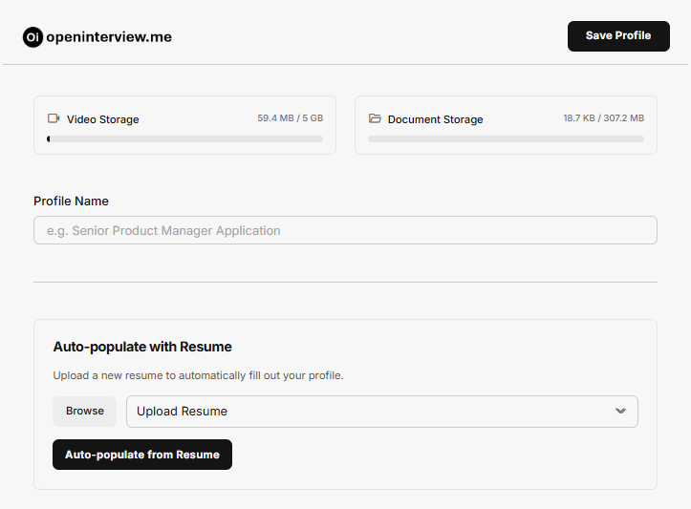

Upload resume (required)
Unlike your first OpenInterview, this step is required.
Why it is required
- This is a new profile with no existing data
- OpenInterview needs a resume to generate content
- All sections (bio, highlights, experience) depend on this input

How to upload
- Click Upload Resume
- Select your file
- Confirm upload

What happens next
After uploading:
- the resume is processed
- profile content is generated
- your profile is auto-populated

Auto-populate profile
Click Auto-populate from Resume to generate your profile.
What this does
OpenInterview will:
- extract your information
- generate your profile structure
- create highlights and summary content
- prepare your profile for editing

Continue profile setup
After auto-population, the flow is identical to your first OpenInterview.
You will:
- review generated content
- click Edit Profile
- refine all sections
- upload your video
- set availability

Key difference from first OpenInterview
Step | First OpenInterview | New OpenInterview
Resume upload | Already completed | Required
Auto-populate | Optional (can skip) | Required
Profile base | Pre-generated | Starts blank

Save your profile
After completing setup:
- Click Save Profile
- Review your profile page
- Confirm all sections are complete

Share your new profile
Once saved, you can:
- click Share
- send via email
- copy your profile link
Each OpenInterview has its own unique shareable link.

Best practices
Create role-specific profiles
Tailor each OpenInterview to a specific job type.
Use different resumes
Upload targeted resumes for better alignment.
Customize messaging
Adjust your bio, highlights, and video to match the role.

You can now manage multiple profiles
Each OpenInterview is independent, allowing you to:
- maintain multiple versions of yourself
- target different opportunities
- share the most relevant profile per application

